IT RCSA Audit Documentation
Business Requirement – BSI.IT.23.C1
Design Assessment, Walkthrough and Sample of One (DH 3264 – Derivatives NDF, Release 01)
DESIGN RATING | SAMPLE 3264 R01 | OBSERVATIONS
SATISFACTORY | PASS | OI-01, OI-03

Control | BSI.IT.23.C1 – Business Requirement (Heracles ID 50696247) – Key, Manual, In every operation
Review period | 09/01/2025 – 08/31/2026
Walkthrough | 08/13/2025 – Jose Luis Martinez Avial, Systems Development Director (prior cycle). 2026 confirmation with the control owner pending.
Sample of one | DH 3264 – Derivatives Non-Deliverable Forwards (NDF), Release 01 – RLSE1270306, production 01/28/2026
Evidence folder | BSI.IT.23.C1 Business Requirement/Evidence (BSI.IT.23.C1.01 – C1.12)

1. Design Effectiveness Summary
The control design is effective. The control is designed with an "In every operation" frequency, which is appropriate because every project that develops a new internal system, customizes a vendor product or upgrades an existing system must have its Business Requirements Document (BRD) approved before it can pass Gate 4 – Prepare to Build (PTB) in Delivery Hub. The nature of the control is manual: the Project Manager drafts the BRD on the US PMO template, the Business Sponsor approves it by e-mail, and the approval is attached to the BRD and uploaded to Delivery Hub for the Gate 4 disposition (Refer to BSI.IT.23.C1.07 – C1.09). The control is formally documented in the 2026 SDLC process map, step 1.1 "Business requirements are defined" (Refer to BSI.IT.23.C1.01). The 2026 control statement adds that exceptions are escalated following the EPMO standard and evidence is stored in the EPMO tool (Delivery Hub). The information supporting execution is moderately reliable: approvals are manual e-mails and some BRD sections are completed with "NA". Overall Rating: Satisfactory.
Note: the 2026 process map is still in Draft status (Date Approved / Approved By blank) and should be finalized by management.

2. WT Summary
No 2026 walkthrough meeting was held for this cycle. The design understanding below is based on the walkthrough performed by IT RCSA on 08/13/2025 with Jose Luis Martinez Avial (Systems Development Director) and on the 2026 SDLC process map "2026 PM_Systems Development Life Cycle (BSI)_v1" (version 2.0, Draft, 05/20/2026; Process Owner: Jose Luis Martinez; BCO: Elizabeth Noda), which shows no change to the control. IT RCSA should confirm with the control owner that the process remained unchanged during the 2026 testing period.
The SDLC process applies only to Application Development projects. The 2026 population is the Delivery Hub "SDLC Project List": 2 projects flagged SDLC = Yes – DH 3263 ALCO – Security Lending and DH 3264 Derivatives Non-Deliverable Forwards (NDF), each delivered in two releases. Both projects were tested in full in the workpaper; this document traces one sample end to end.
Per the 2026 process map the SDLC has three phases – 1.0 Define, 2.0 Build and 3.0 Run & Evolve. During Define, the Line of Business defines the business requirements and the Project Manager documents them in the BRD, which contains:
- Functional requirements: the business requirements (BR #) with scope ID, MoSCoW priority and phase.
- Non-functional requirements: Security, Data Governance, Auditability, Ease of Usability, Performance, Scalability, Reliability, Maintainability, Backup and Recovery, Availability.
- Approvers table (Business Sponsor and approval date), contributors, peer review (not applicable – BSI has no BA CoE role) and revision history.
The Project Manager e-mails the final BRD to the Business Sponsor requesting sign-off, stating that the document and sign-off will be uploaded to Delivery Hub for the Gate 4 disposition. Once signed off, the approval e-mail is embedded in the BRD, and the Gate 4 (PTB) meeting records the disposition and approval date with the area approvals (AML, Operations, Compliance, ISEC, FinCom, ORM, ERM, Technology, BCO, PMO, CDO, etc.). Build starts only after Gate 4. A new release with new scope requires a new BRD and a new Gate 4.
Sample of one: DH 3264 Release 01 was traced end to end – population (BSI.IT.23.C1.02), BRD v1.0 (C1.07), Business Sponsor sign-off e-mail of 10/23/2025 (C1.08), Gate 4 (PTB) approval of 11/04/2025 (C1.09) and the production release RLSE1270306 of 01/28/2026 (C25.08). Results are in Section 3.
Based on our understanding of the process, the control appears to be designed appropriately and implemented as described, and it is adequate to mitigate the risk of insufficient identification and documentation of business and functional requirements (BSI.IT.23.R4 Lack of Design Phase).

3. Sample of One – DH 3264 Derivatives NDF (Release 01)
Workpaper column | Value / conclusion | Evidence reference | Result
Sample ID | 2 (CPA row 54) | Workpaper CPA tab | Pass
Project ID / Name | 3264 – Derivatives Non-Deliverable Forwards NDF (DH 3264 Derivatives OTC Customer Phase 1); PM Domingo Megia Planet | C1.02; C1.07 | Pass
Release | R01 – RLSE1270306 / CHG002670462, production 01/28/2026 | C25.08 (p.1-3) | Pass
BRD defined | BRD v1.0 "Final version" 09/10/2025, US PMO template | C1.07 | Pass
Functional requirements | BR 1 – BR 10: T24 NDF module set-up, pre/post-trade checks, confirmations, middle office, Murex / Medea / 360 integration, Dodd-Frank DTCC reporting, reconciliations | C1.07 §3.1 | Pass
Non-functional requirements | Security (ISAR SAT-4161), Auditability (audit log of NDF orders/trades), Backup & Recovery (RTO 0-8h, RPO 0-4h), Availability | C1.07 §4 | Pass
Business Sponsor | Ted Fernandez, Treasury – Business Owner (= Change Sponsor in Delivery Hub) | C1.07 Approvers; C1.02 | Pass
Business Sponsor approval | E-mail "Consider this my signoff" – 10/23/2025 | C1.08 | Pass
Gate 4 (PTB) disposition | Meeting 10/31/2025, disposition Approved, approval date 11/04/2025 | C1.09 | Pass
Approved prior to Build | 10/23/2025 approval → 11/04/2025 Gate 4 → SIT/UAT 01/2026 → production 01/28/2026 | C1.08; C1.09; C25.08 | Pass
Evidence stored in EPMO tool | BRD with embedded sign-off uploaded to Delivery Hub for Gate 4 | C1.07; C1.09 | Pass
Conclusion: Sample 3264 Release 01 passed both control attributes (BRD with functional and non-functional requirements; Business Sponsor approval before Build); no exceptions were identified. At population level, the Security Lending sample remains pending (OI-01) and population completeness is pending (OI-03).
NewTest Script coverage (workpaper tab 'New Test Script')
Step | Test script step | Sample of one – answer | Result
1 | Obtain Evidence | BRD, sponsor e-mail, Gate 4 record obtained | Completed
2 | Completeness & Accuracy | 3264 traced to RLSE1270306 / RLSE1329424; independent release list pending | Pending – OI-03
3 | Population & Scope | T24 NDF module customization – in scope | Completed
4 | Control Execution | BRD complete; approved 10/23/2025 before Gate 4 11/04/2025 | Pass
5 | Control Results | Approval by Business Sponsor on final v1.0, stored in Delivery Hub | Pass
6 | Exception Handling | No exception for this sample | N/A
7 | Escalation & Remediation | No exception – not applicable | N/A
8 | Risk Mitigation | Requirements defined and approved before Build – R4 mitigated | Pass
9 | Testing Coverage | Documented in workpaper (2 projects / 4 releases) | Completed
Evidence references (BSI.IT.23.C1 folder)
Ref | Evidence | What it shows for 3264 R01
C1.01 | 2026 PM_Systems Development Life Cycle (BSI)_v1.pdf | Step 1.1 "Business requirements are defined" – control C1 (v2.0 Draft)
C1.02 | SDLC Project List (population).xlsx | 3264 – SDLC = Yes, T24, Closed 09/02/2026, Change Sponsor Ted Fernandez
C1.07 | NDF R01 – DH 3264 Business Requirements Document_final.docx | BRD v1.0: BR 1-10, NFRs, Approvers table Ted Fernandez 10/23/2025 (Exhibit A2)
C1.08 | NDF R01 – BRD Sponsor Sign-off email 10-23-2025.msg | "Consider this my signoff" – Ted Fernandez 10/23/2025 (Exhibit A3)
C1.09 | NDF R01 – Delivery Hub Gate 4 (PTB) approval 11-04-2025.pdf | Gate PTB (4), R01, meeting 10/31/2025, Approved 11/04/2025 (Exhibit A1)
C25.08 | NDF R01 – RLSE1270306 ServiceNow Release ticket.pdf | Production deployment 01/28/2026 – after Gate 4

Appendix A – 3264 R01 Evidence
Exhibit A1: Delivery Hub "BSI Gate approvals (Waterfall)" – Project 3264, Gate PTB (4), Release R01
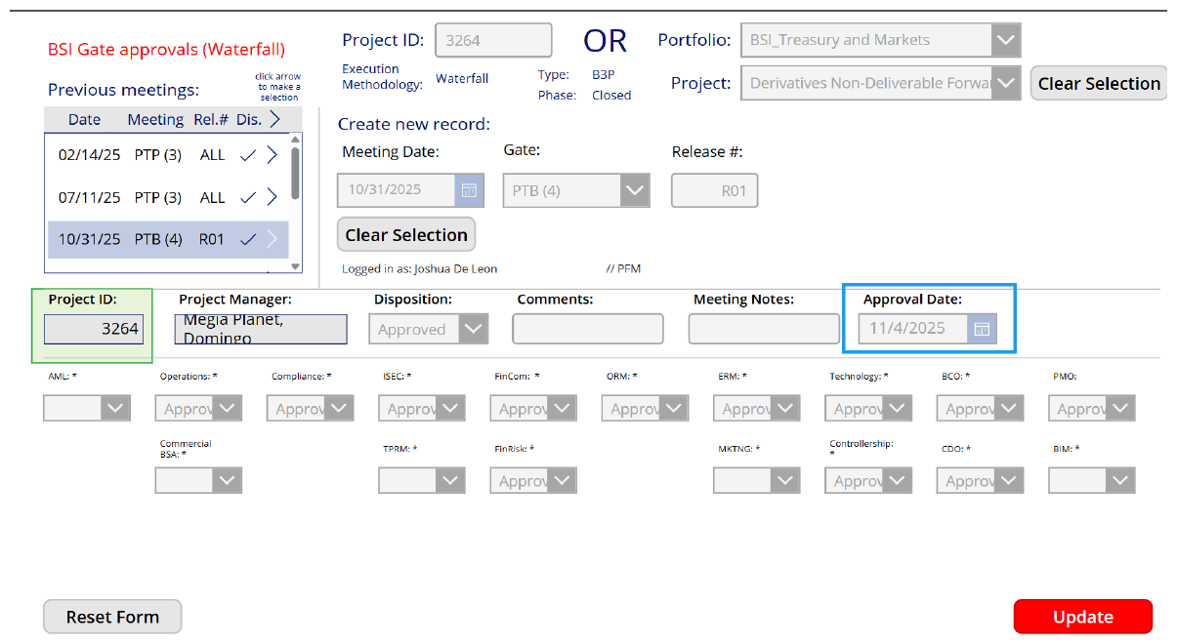
Source: BSI.IT.23.C1.09 – NDF Release 01 Gate 4 approval date.pdf. Highlighting as included in the evidence provided.
Exhibit A2: BRD approvers table and revision history (BSI.IT.23.C1.07)
Document | DH 3264 - Derivatives OTC Customer Phase 1 (NDF) – Business Requirements Document (US PMO Template)
Originated by | Domingo Megía (Project Manager Lead)
Approver | Treasury – Ted Fernandez – Treasury – Business Owner – 10/23/2025
Contributors | Domingo Megia (Project Manager Lead); Ricardo Valdivia (Product Owner – Treasury)
Revision history | 1.0 – 09/10/2025 – Final version – Domingo Megia
Exhibit A3: Business Sponsor sign-off e-mail (BSI.IT.23.C1.08)
From / Sent | Ted Fernandez / Thursday, October 23, 2025 13:28 UTC
To / Cc | Domingo Megia Planet / Ricardo Valdivia; Marcus Medeiros Carneiro Simoes
Subject | RE: **Sign-off required* - DH 3264 - Derivatives OTC Customer Phase 1 - Business Requirements Document
Message | "Consider this my signoff" – in reply to D. Megia: "…to receive your sign-off… this document along with your sign-offs will be uploaded into Delivery Hub as part of documentation required for GATE 4 deposition."
Referenced workbook: WP 2026 BSI.IT.23.C1 Business Requirement.xlsm – tab "Control Performance Assessment", row 54; tab "New Test Script".

